This assignment has two parts.
Part One: Programming
Write a program to display a message to the screen. The message may be a poem, song, or information about you. Use the following guidelines to write your program:

- Use the Python IDLE to write your program.
- Using comments, type a heading that includes your name, today’s date, and a short description.
- Decide on the message you would like to display to the screen. Some ideas include:
- Your favorite poem or song
- A few sentences sharing information about you
- Set up your def main(): statement.
- Don’t forget the parentheses and colon!
- Use at least five print statements to display your message to the screen.
- Conclude the program with the main() statement.
- Follow the Python style conventions regarding indentation in your program.
- Run your program to ensure it is working properly. Fix any errors the interpreter or you may observe.

Example of expected output: The screen shot below is an example of an “all about me” message. Your specific results will vary depending on the choices you make about your message.

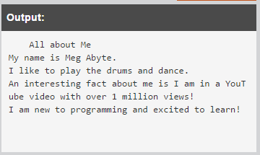

Insert your program code here:

# Shashank Navale
# 06/13/2020
# Purpose: To display a message: poem, song, or info about me

def main():
print("All about me")
print("My name is Shashank Navale.")
print("I am 16 years old.")
print("I love to code, and I am fluent in JAVA and C.")
print("My favorite sports are Cricket, Formula 1 and Soccer.")
main()

Part Two: Post Mortem Review
Complete the Post Mortem Review (PMR). Write thoughtful two to three sentence responses to all the questions in the PMR chart.
Review Question | Response
What was the purpose of your program? | The purpose of my program was to display information about me on the screen. It also allowed me to practice my Python skills.
How could your program be useful in the real world? | My program can be useful in the real world when someone needs to know more about me or I need to give someone an introduction, I can just show them the program and run it.
What is a problem you ran into and how did you fix it? | One problem I ran into was when I added colons to the ending “main()” function and it kept giving me a syntax error. I realized it and fixed it later.
Describe one thing you would do differently the next time you write a program. | I would pay attention to the main() function and not include the colons next time now that I have learned not to do so. I also learnt that Python is case sensitive, I should pay attention to it.

